
2009 Annual Report

Redbridge School Monitoring Station
The nitrogen dioxide annual mean was 39.9µg/m³, right on boundary of the 40µg/m³ standard, a decrease on 2008 when it was 44 µg/m³. A peak hour concentration of 161 µg /m³ was recorded, with no exceedance of the 1 Hour Standard. PM₁₀ concentrations averaged 24.5 µg/m³, with 4 exceedences of the 24 hour standard, 6 days less than 2008. Redbridge School had the highest annual mean for PM₁₀ in Southampton. This is unsurprising as it is only 8 metres from Redbridge Road which has the highest overall traffic flow and highest number of HGVs in the City. The Teom data was bias corrected in accordance with the Volatile Correction Model.

Bitterne Monitoring Station
The annual mean nitrogen dioxide level for 2009 was 34.4 ug/m³, an improvement on 2008 which was 39.2µg/m³ . A peak hour concentration of 145 µg/m³ was recorded with no exceedance of the 1 Hour Standard.
PM₁₀ concentrations averaged 21.4 µg /m³, slightly less than 2008, with only 4 days of exceedence of the PM₁₀ daily standard, compared to 7 days in 2008 . The Teom data was bias corrected in accordance with the Volatile Correction Model.

AURN Brintons Road (Six Dials)
An annual mean of 35µg/m³ was recorded for nitrogen dioxide, a decrease of 1 µg/m³ from 2008 with a peak hour of 141µg/m³. There were no exceedances of the 1 hour standard.
The AURN recorded 3 exceedences of the PM₁₀ daily mean standard in Southampton, a reduction from 2008 when it recorded 7 days. The PM₁₀ annual mean concentration was 18µg/m³ using the new gravimetric equivalence method FDMS, a reduction of 2 µg/m³ on 2008.

Onslow Road
Onslow Road recorded 44ug/m³ for nitrogen dioxide annual mean, a significant decrease compared to 2008’s 51.4 µg/m³, but still above the annual mean standard. There was 1, One Hour exceedance of the 200 ug/m³ standard, compared to 5 in 2008.
This monitoring station is located within the Bevois Valley Air Quality Management Area.
The station suffered from a prolonged power failure in late January, February and half of March, reducing data capture to only 83%. This was due to electrical problems from the adjacent lamp post where the power is sourced.

Millbrook Road
A mean of 50µg/m³ for nitrogen dioxide was recorded, well above the annual mean standard, but a small reduction on 2008.. There were no exceedances of the One Hour Standard.
The peak hour for this period was 142µg/m³.
Data capture for 2009 was 98% a big improvement on 2008 when technical issues kept data capture below 90%.

Overall air quality in 2009 at all of our stations improved upon that monitored in 2008. This may, in part be attributable to the wet, windy summer weather we endured and economic recession. Hopefully it also reflects the success of the air quality action plan/local transport plan and improved emission reduction from newer vehicles helped by the government’s car scrappage scheme in 2009.

Comment on TEOM PM₁₀ Data The new statistical method for correcting TEOM data using the Volatile Correction Model appears to have resulted in lower annual means and number of days of exceedance since the method was introduced in 2008, replacing the 1.3 correction factor.

Monitoring results for 2009

 | Monitoring Site
Pollutant | Redbridge | Bitterne | Six Dials (AURN) | Onslow Road | Millbrook Road
Particulates (PM₁₀) µg/m³  PM _{2.5} | Average of 24.5µg/m3,  peak day of 65ug/m³ on the 26th May  4 days above the daily mean standard  Data Capture 94%  N/A | Average of 21.4 µg/m³, peak day of 60µg/m³ on the 23rd January, 4 days above the standard  Data Capture 91.3%  N/A | Average of 18µg/m³,  Peak day of 65µg/m³  3 days above the standard.  Data Capture 96.8%  Average of 13µg/m³ Maximum daily mean of 61µg/m³ DC 97% | N/A  N/A | N/A  N/A
Nitrogen Dioxide µg/m³ | Average of 39.9µg/m³  peak hour of 161µg/m³ on 25th May  Data Capture 87% | Average of 34.4µg/m³,  peak hour 145µg/m³ on 23rd January  Data Capture 95% | Average of 35µg/m³,  peak hour of 141µg/m³  Data Capture 96.2% | Average of 43.8µg/m³,  1 hourly mean above 200 ug/m³ . 269 µg/m³ on 23rd December Data capture 82% | Average of 50µg/m³, peak hour of 141.7µg/m³. 0 hourly mean above 200ug/m³ Data capture 98%
Sulphur Dioxide  µg/m³ | N/A | N/A | Average of 2µg/m³  peak 15 minute of 93µg/m³  Data Capture 96.6% | N/A | N/A
Carbon Monoxide  mg/m³ | N/A | N/A | Average of 0.2mg/m³  peak 8 hour mean of  1.1mg/m³  Data Capture 97.7% | N/A | N/A
Ozone  µg/m³ | N/A | N/A | Average of 33µg/m³  peak 8 hour mean of 107µg/m³ 5 Rolling 8 hour Periods above 100ug/m3  Data Capture 96.0% | N/A | Average of 32.3 ug/m³  2 days with Rolling 8 hour Periods above 100 ug/m3  Data Capture 99%
Benzene  µg/m³ | N/A | N/A | Average of 0.85µg/m³  100% data capture  (pumped diffusion tube) | N/A | N/A
(µg/m³ = micrograms per cubic metre, ppb = parts per billion, N/A= Non applicable mg/m³ = milligrammes per cubic metre
Nitrogen Dioxide Annual Mean 2001-2009
0
10
20
30
40
50
60
2001
2002
2003
2004
2005
2006
2007
2008
2009
year
ug/m3
redbridge
bitterne
six dials
onslow road
millbrook road
40 annual mean standard
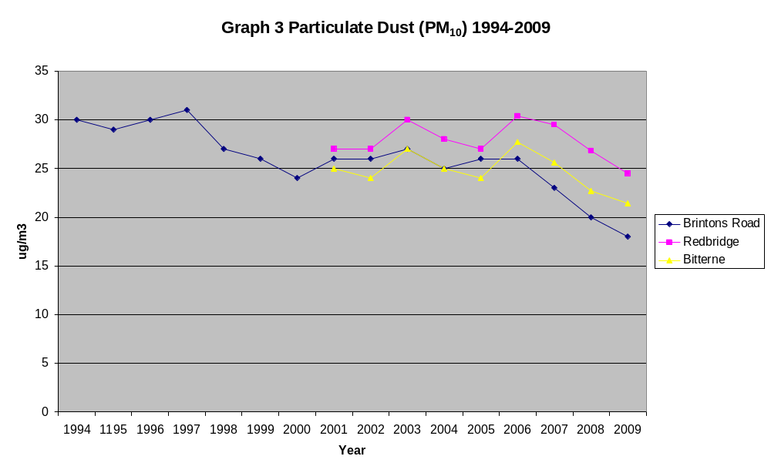

Description of the Monitoring Stations in Southampton

AURN – Brintons Road (Six Dials)

DEFRA Automatic Urban Network Station, Brintons Road, by Six Dials Junction, established 1994, classified as an Urban Centre site. This site is approximately 8 metres from the kerb of Northam Road and has around 33,000 vehicles per day (3.5% HGV). Pollutants monitored at this site include NO_{x}, SO₂, O₃, CO, PM₁₀ and benzene (by pumped diffusion tube). It is in a residential area with houses close to the road. O.S. Grid Ref: 442583, 112248.

Bitterne

Mobile Unit located at Bitterne Road in the railway station car park. Pollutants monitored include NO₂ and PM₁₀. This is a residential area approximately 10 metres from Bitterne Road/Bullar Road Traffic Lights and close to railway line. It has 33,000 vehicles per day, 3.5% HGV, 30mph speed limit. The monitoring station is located on the edge of the Air Quality Management Area. O.S. Grid Ref: 443987, 113340

Redbridge

The monitoring station at Redbridge Community School was established April 1999. It is situated approximately 8 metres from the kerb of Redbridge Road and is the most heavily trafficked road in Southampton, comprising of a 3-lane dual carriageway, and 50-mph speed limit. This road is the designated route into the port for HGVs. Average Daily Traffic count of 76,000 vehicles per day, 8% HGV. The pollutants monitored include NO_{x} and PM₁₀. A residential area with several schools and sports grounds next to the road.
O.S. Grid Ref: 437549, 113721.

Onslow Road

This site is located 2 metres from the kerb and is opposite 3 Onslow Road. It lies within the Bevois Valley AQMA and was established in July 2005. Onslow Road has 18,000 vehicles per day, 2.6% HGV and a 30mph speed limit. This site only monitors oxides of nitrogen. O.S. Grid Ref: 442304, 112771.

Millbrook Road

This site is located at the junction of Millbrook Road/Waterhouse Lane, Freemantle. It lies within the Millbrook Road AQMA, established September 2007. The site is funded by Marchwood Power Station as part of a planning condition to monitor emissions downwind of the stack. Pollutants monitored are NO_{x} and O₃. The site is situated 6 metres from the kerb, and has 53,000 vehicles per day (4.5% HGV).
Grid Reference: 439702,112768

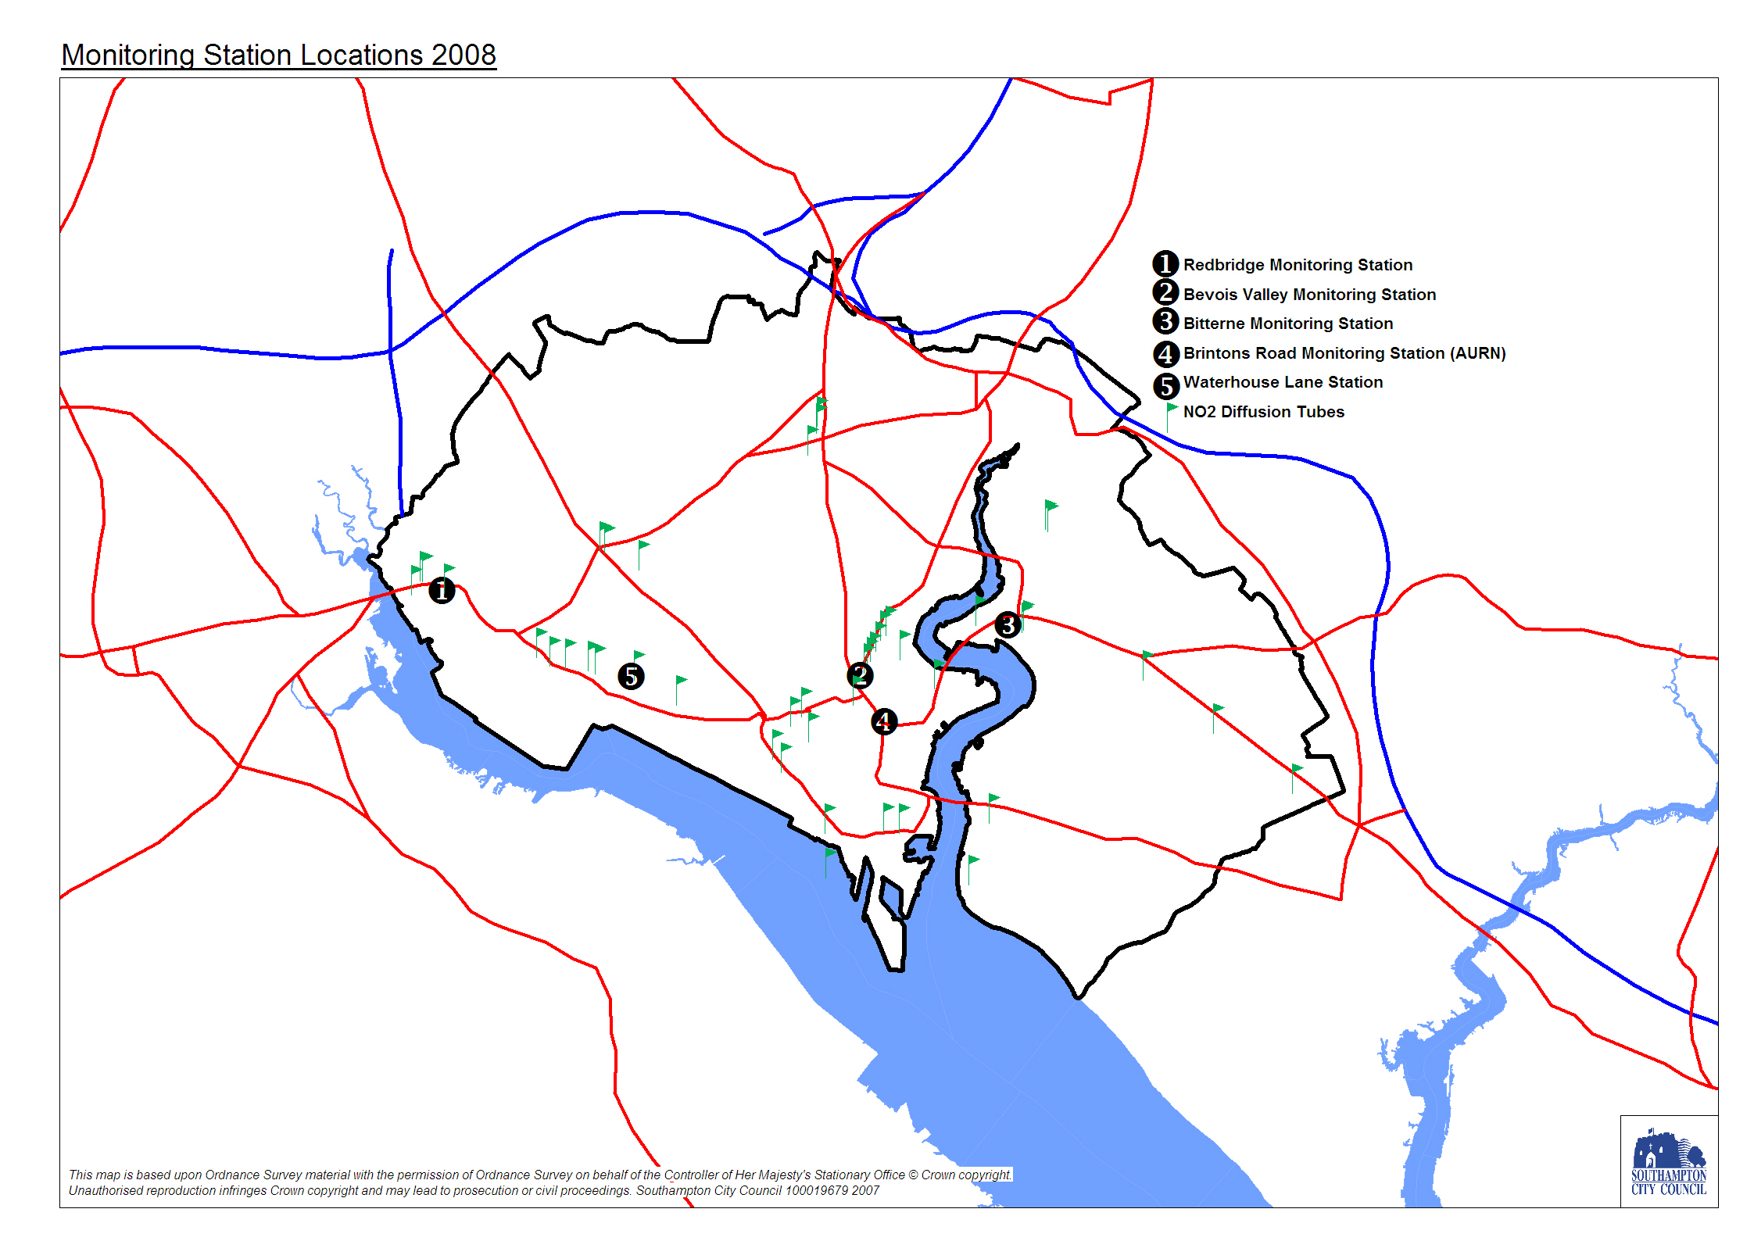

National Air Quality Standards

The table below summarises the National Air Quality Standards which are set out in the National Air Quality Strategy. Southampton City Council has a statutory duty to achieve these standards by the assigned date.

Pollutant | Air Quality Objective |  | Date to be achieved by
 | Concentration | Measured as
Particles (PM₁₀) | 50µg/m³ (gravimetric) not to be exceeded more than 35 times a year (TEOM data multiply by 1.3) | Daily (24 hour mean) | 31.12.2004
Nitrogen Dioxide | 105 ppb (200µg/m³) not to be exceeded more than 18 times a year | 1 hour mean | 31.12.2005
 | 21 ppb (40µg/m³) | annual mean | 31.12.2005
Sulphur Dioxide | 132 ppb (350µg/m³) not to be exceeded more than 24 times a year | 1 hour mean | 31.12.2004
 | 47 ppb (125µg/m³) not to be exceeded more than 3 times a year | 24 hour mean | 31.12.2004
 | 100 ppb (266ug/m³) not to be exceeded more than 35 times a year | 15 minute mean | 31.12.2005
Carbon monoxide | 10ppm (11.6mg/m³) | running 8-hour mean | 31.12.2003
Benzene | 5.00ug/m3 | annual mean | 31.12.2010
1,3 Butadiene | 1ppb (2.25ug/m³) | running annual mean | 31.12.2003
Lead | 0.5ug/m³ | annual mean | 31.12.2004
 | 0.25ug/m³ | annual mean | 31.12.2008
Ozone | 50 ppb (100ug/m³) not to be exceeded more than 10 times a year | Daily maximum of running 8 hour mean | 31.12.2005

